Heavy Weight #5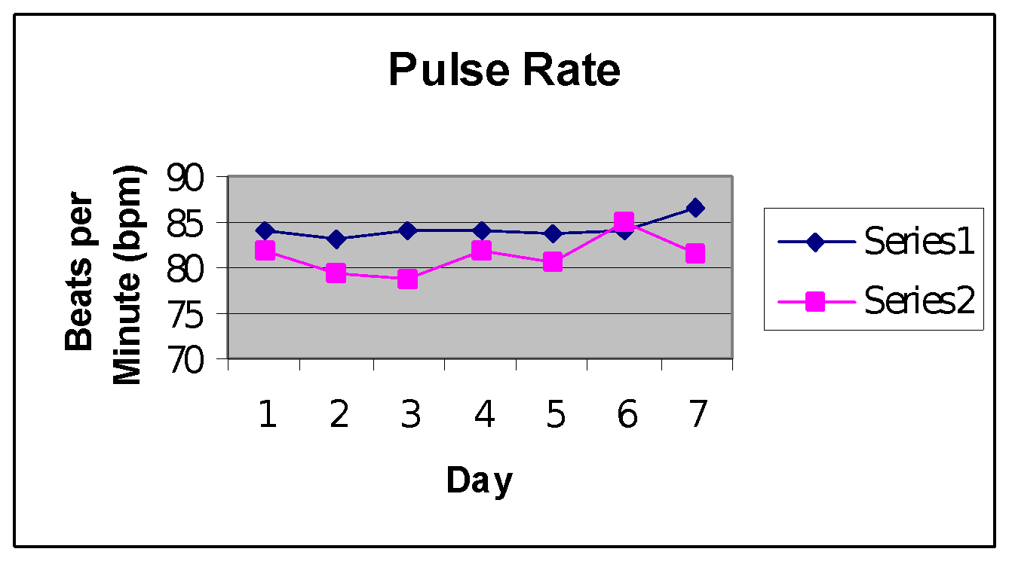

**Series #1 w/o strip; Series #2 w/ strip**

# Series #1 mean: 84.189 bpm; Series #2 mean: 81.276 bpm

The Series #2 mean has less than a .01 probability of occurring by chance when compared to the Series #1 mean. This gives strong evidence that the nasal strip decreased the subject’s pulse rate.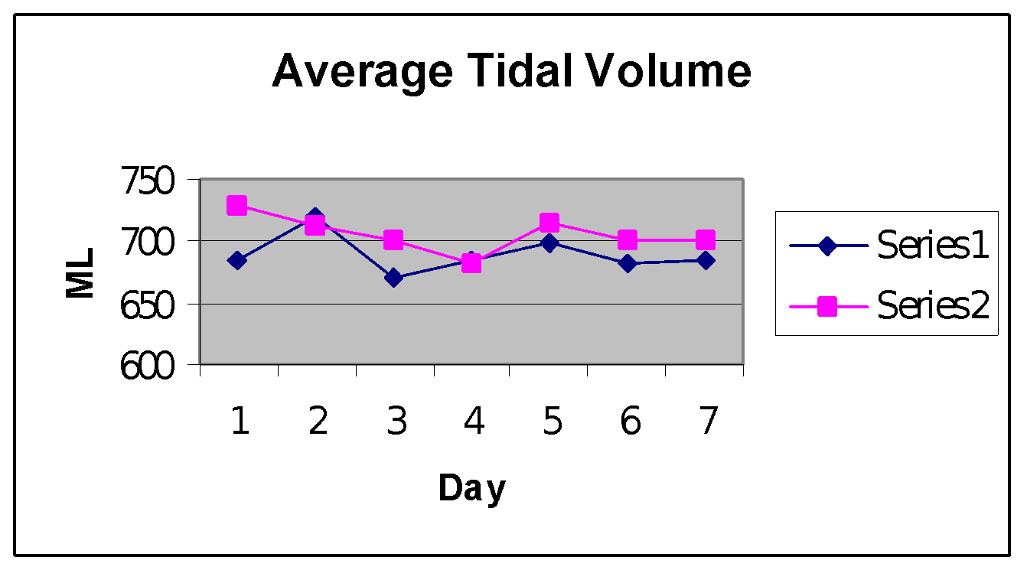

Series #1 mean : 689.5098 ml; Series #2 mean: 705.6607 ml

The Series #2 mean has a .0713 probability of occurring by chance when compared to the Series #1 mean. This show strong evidence that the nasal strip increased the subject’s tidal volume.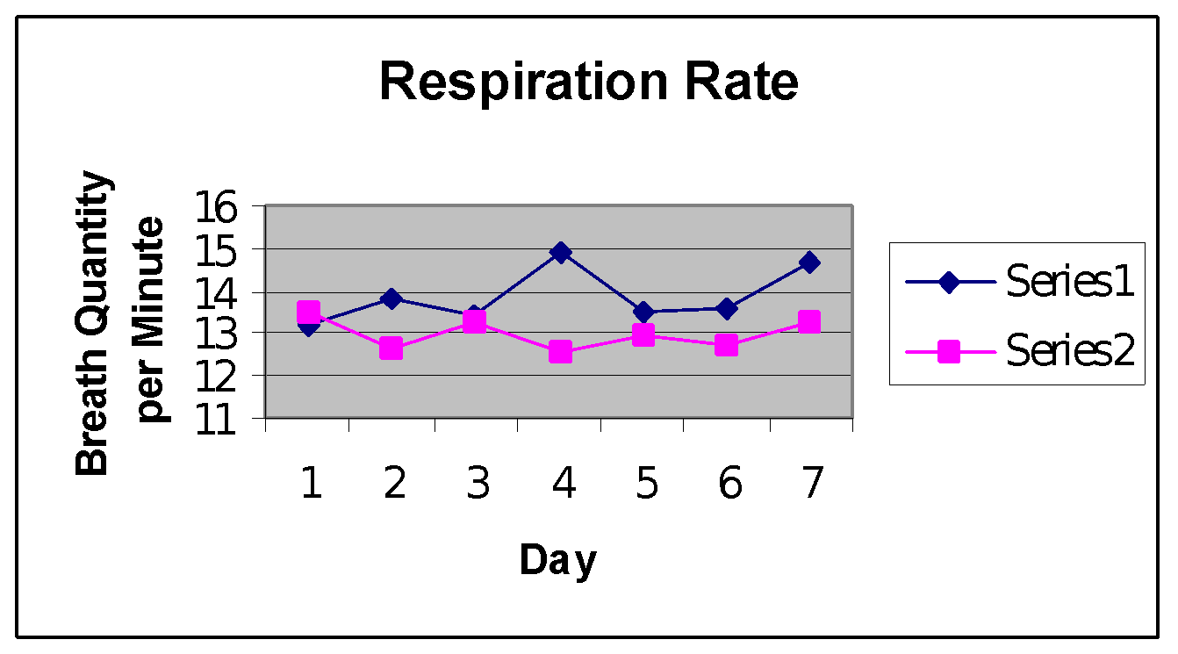

Series #1 mean: 13.8692 bqpm; Series #2 mean : 12.977 bqpm

The Series #2 mean has a .0145 probability of occurring by chance when compared to the Series #1 mean. This shows strong evidence that the nasal strip decreased the subject’s respiratory rate.

Series #1 mean 286,764.035 ml; Series #2 mean: 274,720.77 ml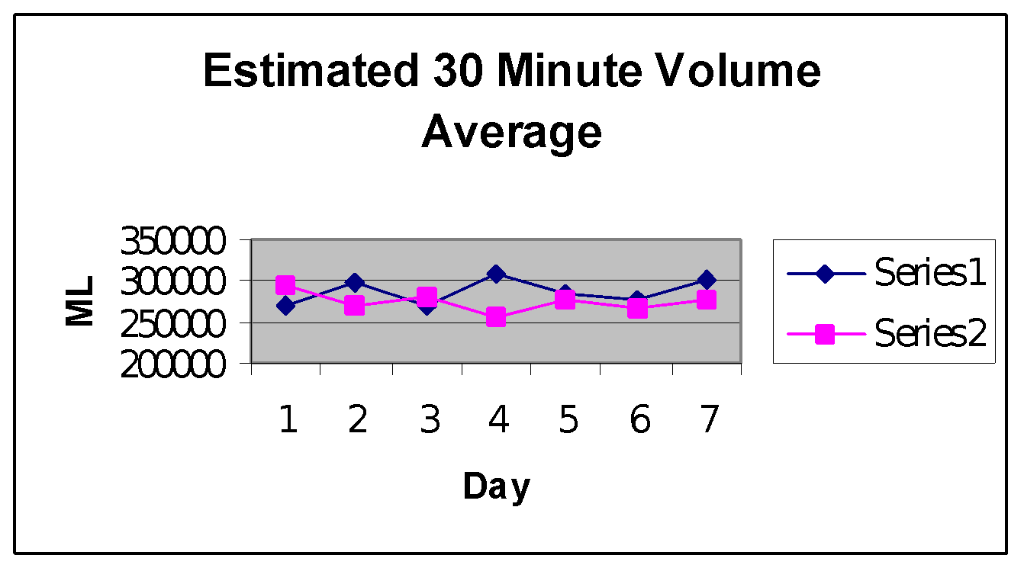

The Series #2 has a .415 probability of occurring when compared to the Series #1 mean. This shows weak evidence that the nasal strip either increased or decreased the subject’s 30 minute volume.